**Lifekidz Distress Reduction, De Escalation and Management of Risk Policy**

**Purpose**

To provide a safe haven for all, by minimising and reducing distress, Lifekidz Management and staff shall ensure effective procedures are in place around behaviours that are challenging to others and the use of physical restraint.

Dignity, respect and mana are central to this Lifekidz policy and to our thinking and actions.

**Reducing distress**

* By acknowledging that participants are experiencing distress means that we hold central to our beliefs that something is ‘happening to or within’’ our participants that is causing distress and that we have a part to play in trying to understand what that is and how we might best minimise it.
* In order to reduce distress, we need to gain an in-depth understanding of
* a) the roots and causes of behaviour and
* b) how their actions serve to either calm (and make them feel safe) or cause further distress.

**What is significant emotional distress?**

* In the context of legislation, significant emotional distress means harm that is caused by the intentional acts of one person that significantly affects the emotional wellbeing of another person, to such an extent that they need intensive support to cope and recover.

**Staff training and professional learning and development**

* Lifekidz has a long history of training all staff in positive and preventative measures where our participants behaviour is concerned.
  + Lifekidz has had a consistent history of De-Escalation Management
  + This programme has had several evolutions over the last 20+ years and became MAPA

(Managing Actual and Potential Aggression) and more recently changed to SI (Safety Intervention)

* + Lifekidz sees the Safety Intervention Basic training and subsequent refresher training as a part of the ongoing professional development and learning for all staff. Hence all staff are trained / refreshed every year.
  + A positive and proactive approach to participant behaviour is now embedded in Lifekidz ways of working.

**How we view behaviour**

At Lifekidz we believe that

* + Creating a safe haven for all is our ultimate aim.
  + Our participants don’t misbehave - and so we see all behaviour as stress behaviour.

- 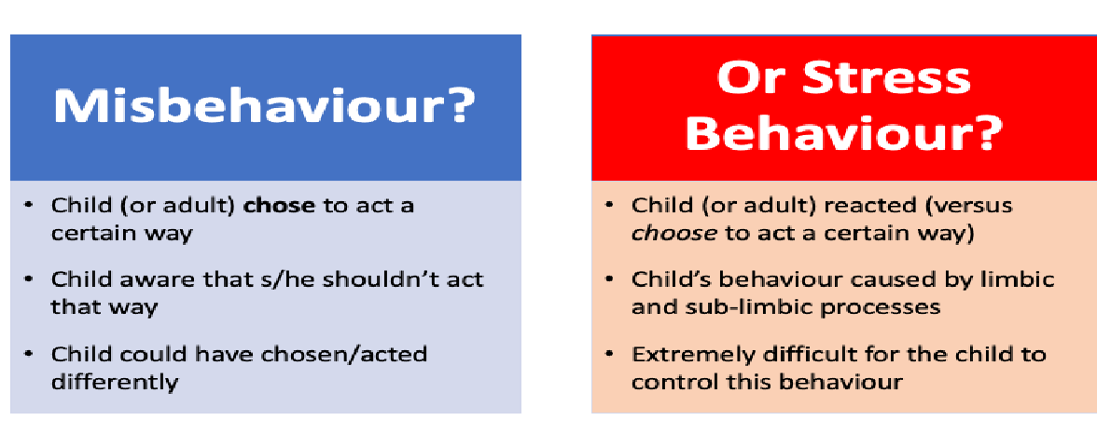

* + By using a neurobiological lens for learning and care, and not behaviour management, we understand students’ behaviours are a result of their physiological states, not intent.
  + Starting from a place of safety will help us to select programmes, initiatives and ways of working that contribute to enhancing and strengthening the wellbeing of all.
  + The best place to start is with relationships and that all relationships begin with co-regulation.
  + Regulation occurs in the brain stem (NOT the cortex!). It comes from feeling safe, having a feeling of security and connectedness with others - not from being told to ‘be calm’.
  + Our approach to supporting learning wellbeing (behaviour) must be explicitly aligned with our values see Principles chart below.

|  |  |  |
| --- | --- | --- |
| **Principles** | **Our values / aims** | **Positive Behaviour Support** |
| **Whakamana** | To be accepted and celebrated, have a sense of identity and self-worth. Talents and strengths are recognised and nurtured. | Acknowledging the participants voice (the why)  Using behaviour may be the ‘best’ way a student has to communicate at that time.  Below every behaviour is an unmet need. |
| **Whanaungatanga** | To foster a sense of belonging and whānau connection in a caring community that ‘gets me’. | Managing behaviour in the context of relationships - relationships come first. Relationships and a sense of belonging are central to a healthy and productive school learning community. |
| **Manaakitanga** | To participate and contribute meaningfully in the community in ways that uplift mana. | Relationships are the fundamental vehicle for survival, work, learning and love. “The currency for systemic change was trust, and trust comes through forming healthy working relationships.” (Bruce Perry) |
| **Hauora** | To be happy, safe and healthy in mind, body, spirit and relationships. | Supporting wellbeing by:   * Being proactive * Developing preventative strategies * Being responsive to participants needs |
| **Māhirahira** | To be genuinely curious in a culture that promotes courage and risk taking in ongoing learning. | Staff move into detective mode - we try to figure out what’s going on for them - they are having a tough time.  We are co regulators for our participants   * we are empathetic and try to understand * we use tools to give more information |
| **Ako** | To engage in the reciprocity of supporting and learning to become a confident and competent learner and communicator. | The only influence we have over participant behaviour is our own response (adapting our behaviour, the environment or teaching new skills).  We can’t make anyone do anything. |

**What is physical restraint?**

Physical restraint is using physical force to prevent, restrict, or subdue the movement of a participants body or part of their body. It is a serious intervention used only as a last resort to protect others from harm.

**Who can use physical restraint at Lifekidz**

Physical restraint can only be used by staff who are suitably supported and trained for this task.

**When can physical restraint be used at Lifekidz?**

Lifekidz limits the use of physical restraint by staff to situations where:

* The staff reasonably believes that the safety of the participant or of any other person is at serious and imminent risk.
* the restraint used is reasonable and proportionate in the circumstances.
* it is used as a last resort; and
* it is only used for the duration that the threat to safety exists.

**Lifekidz identifies serious and imminent risk to safety as:**

* Participant moving in with a weapon, or something that could be used as a weapon, and is clearly intent on using violence towards another person
* Participant is physically attacking another person
* Participant is throwing furniture, computers, or breaking glass close to others who could be injured
* Participant putting themselves in danger, for example running onto a road or trying to harm themselves.

**Lifekidz identifies acceptable physical contact as the following and in all cases is used to uphold first and foremost a participant’s dignity and respect**

* Supporting participants to move from one location to another, or help them get into a vehicle or use the stairs
* Temporary physical support, such as open hand on arm, back or shoulders to remove them from a situation to a safer place.
* The temporary use of a ‘Transition’ hold to assist a participant to move from one location to another (as part of a de-escalation process, to maintain dignity by moving from an area where there are onlookers, or to minimise risk to others).
* The practice of harness restraint (when keeping participants and others safe in a moving vehicle or other positioning equipment (such as standing frames etc) when recommended by a physiotherapist or occupational therapist for safety or body positioning.
* Physically support to develop skills and attempt something new.
* Holding their hand to accompany them somewhere.
* Assisting with toileting, including changing a nappy.

**Lifekidz ensures that**

* practices are clear, follow the rules, are well-documented, and available to all.
* systems are in place that include keeping written records and following requirements to notify, monitor and report on the use of physical restraint.
* policies and guidelines on physical restraint are available for all participants whānau, parents and caregivers.

Complainants with concerns regarding use of physical restraint must follow the prescribed concerns and complaints procedure.

**Policy Review Date:** July 2024